Installation:
Select option 2 to install the latest version of INET Framework and OMNeT++
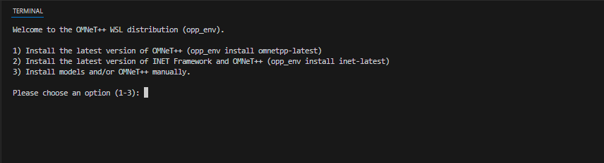
- After the successfully the OMNeT++ installed.
- Type the omnetpp command in the terminal to start the IDE++.
- Launcher Window will be opened.
- Select a directory for a workspace and click on the Launch Button.
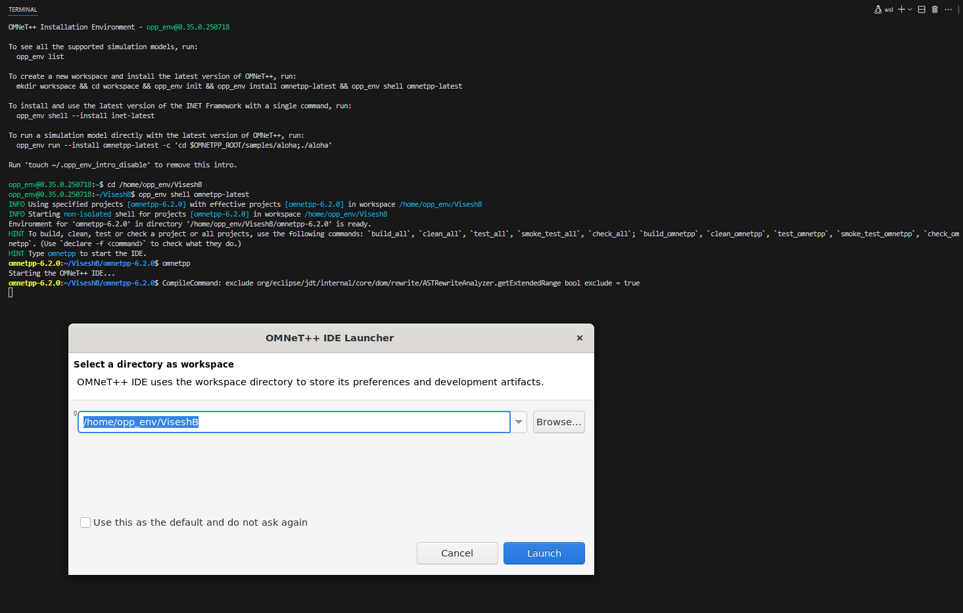

To verify the Simulator is working tried with aloha project.
By giving the below commands in the Terminal.
cd samples/aloha
./aloha
and Ran the project the simulator is working properly.
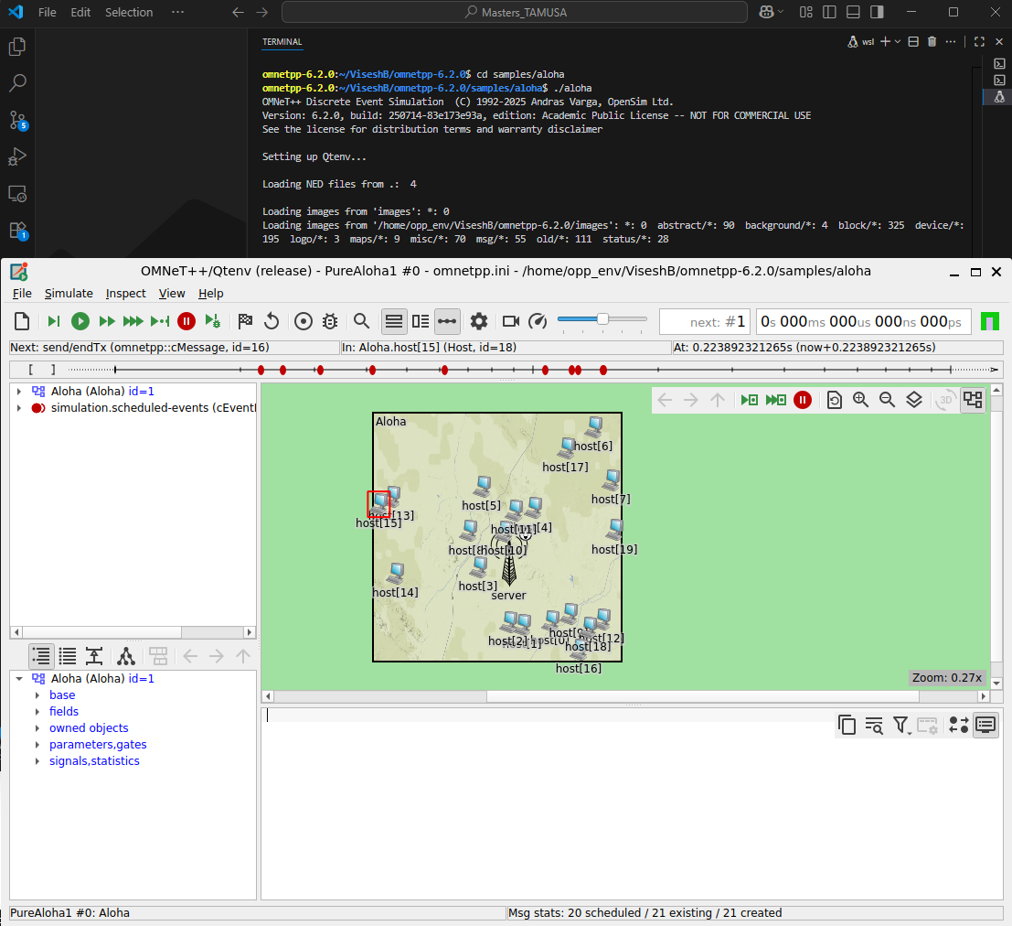
Here is the Simulator Window before starting the project.
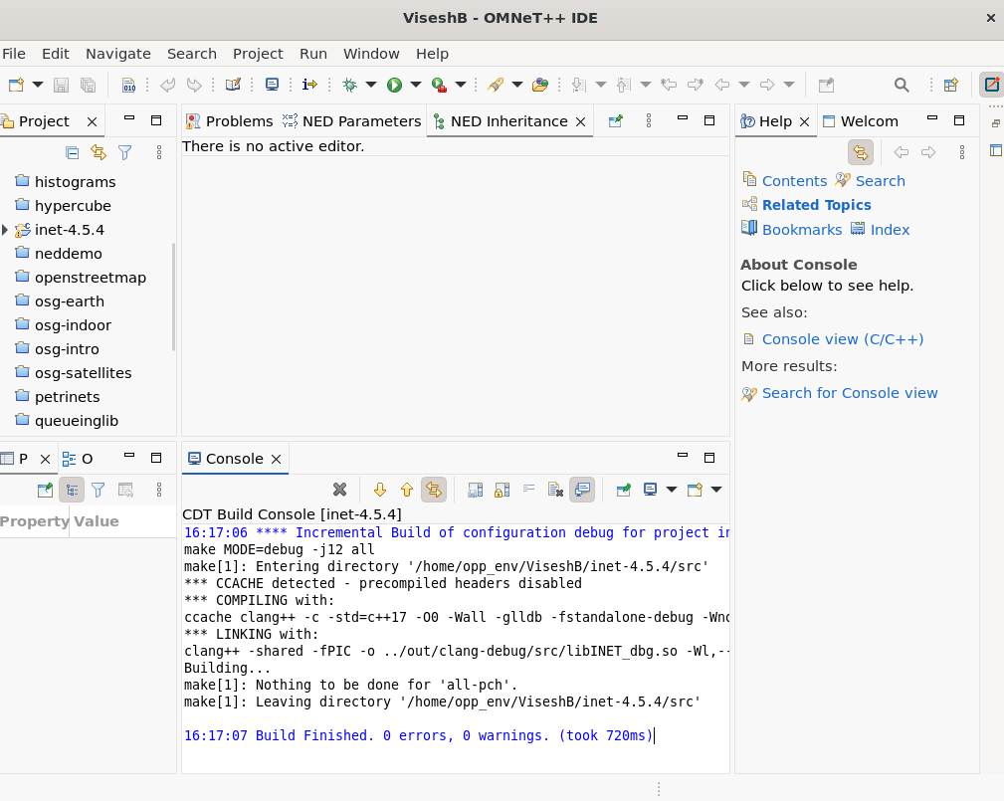

Tictoc:
Right click on the Omnetpp.ini, select the event log and the enable the configuration Tictoc1,Tictoc6 and TicToc9.
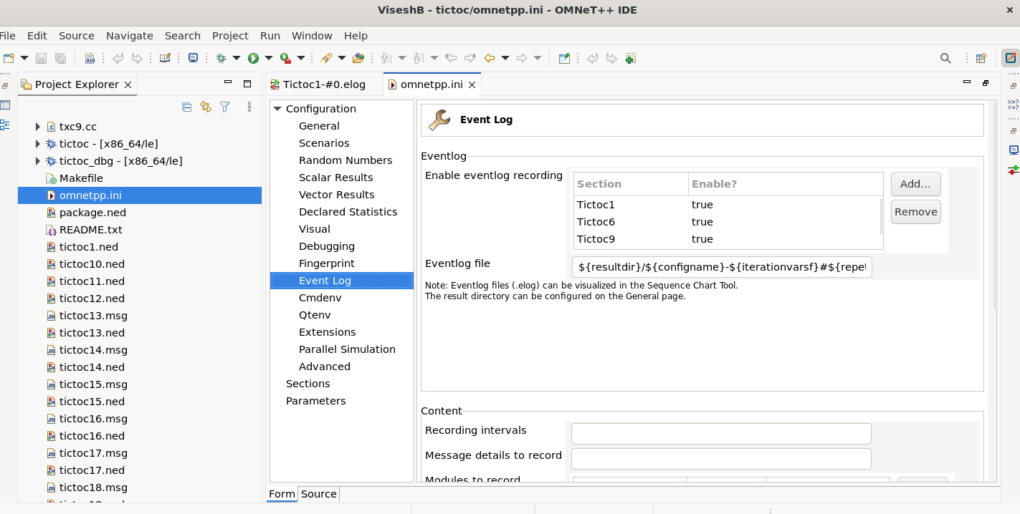
In the below image shows the TicToc 1 is connected between the two nodes Tic and Toc.
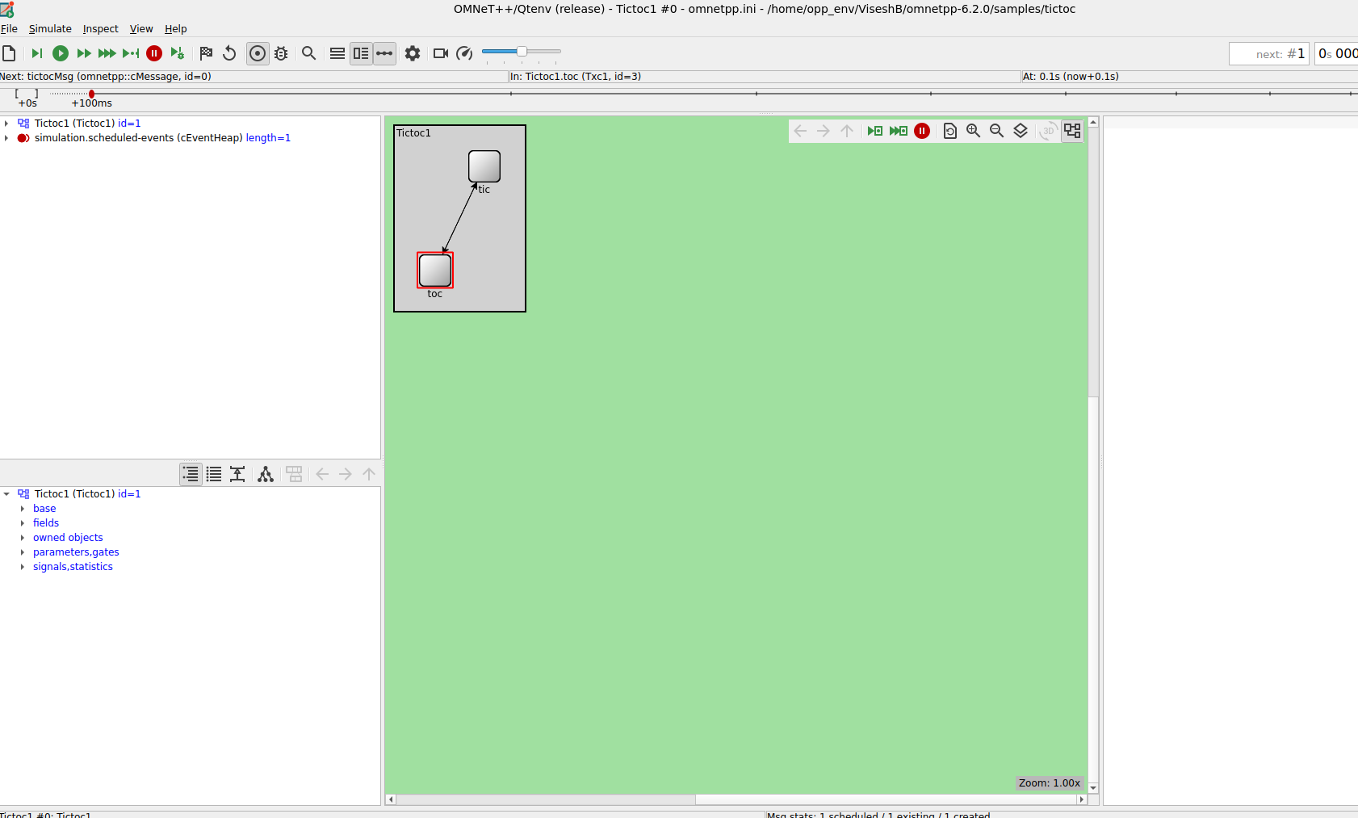

To Run the OMNeT++ Simulation, right click on Omnetpp.ini then select Run As the option 1 OMNet++ Simulation
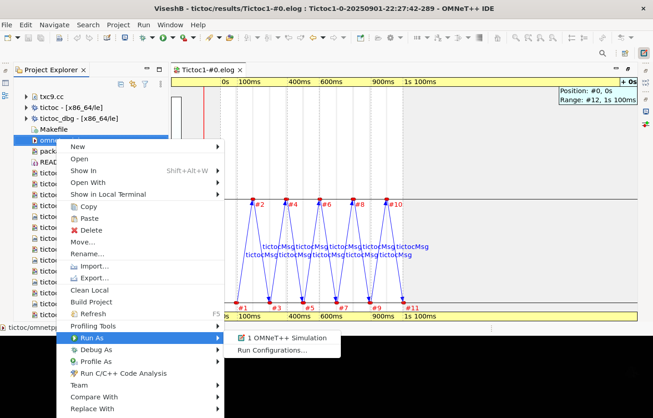

The graph below shows the message between the tic and toc and events are executed in sequence.
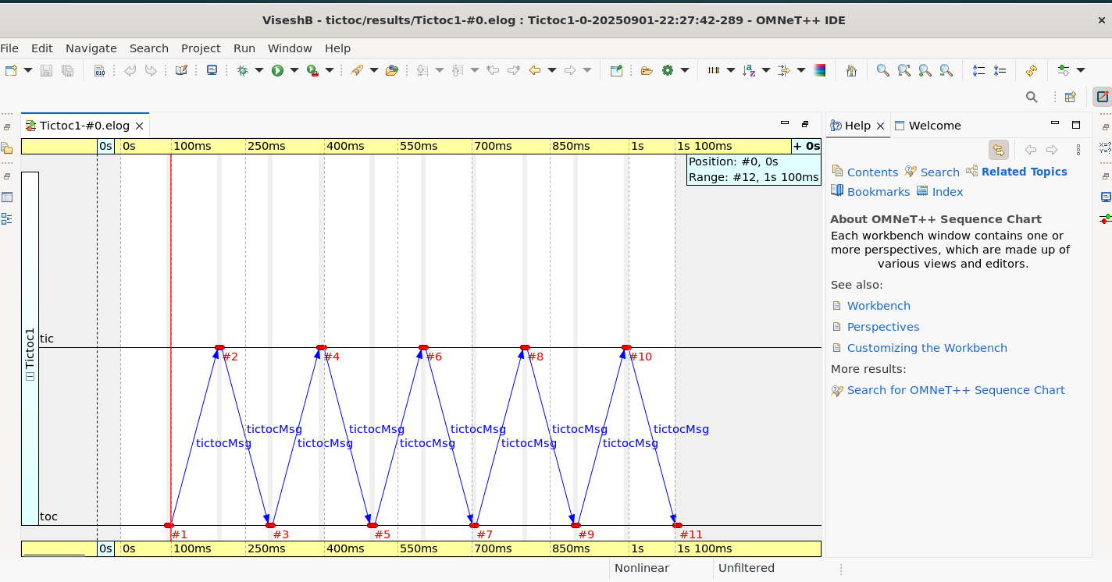

By default in tictoc9 there is only 2 nodes so I have to implement 6 nodes. So I edited the code in ned editor and I also had to edit the txc9.cc file as well.
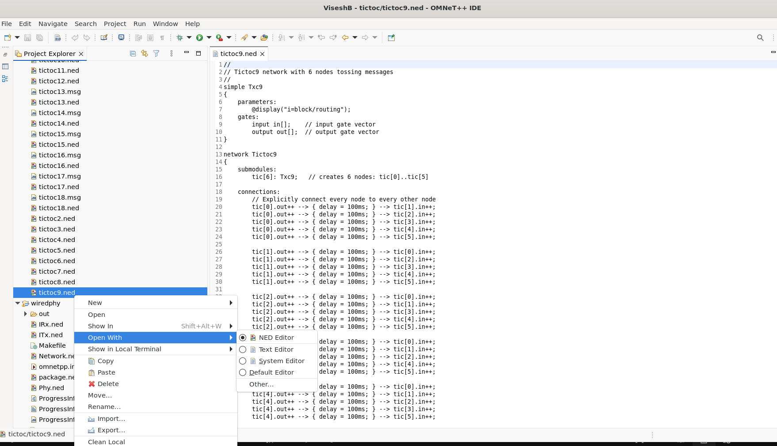
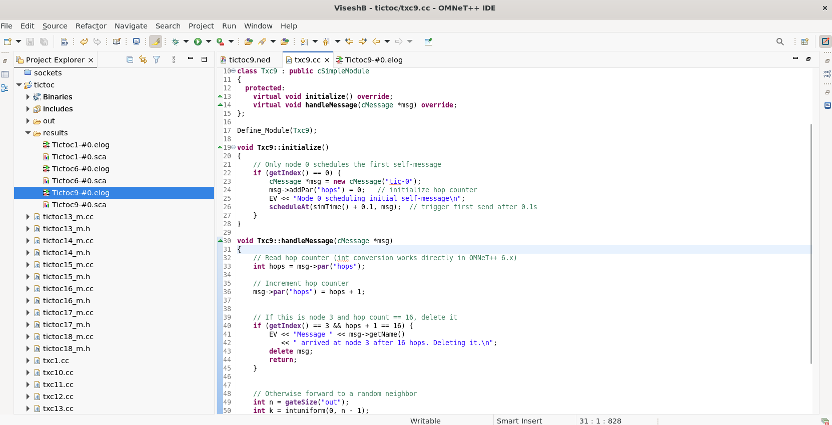

Tictoc9.ned file:
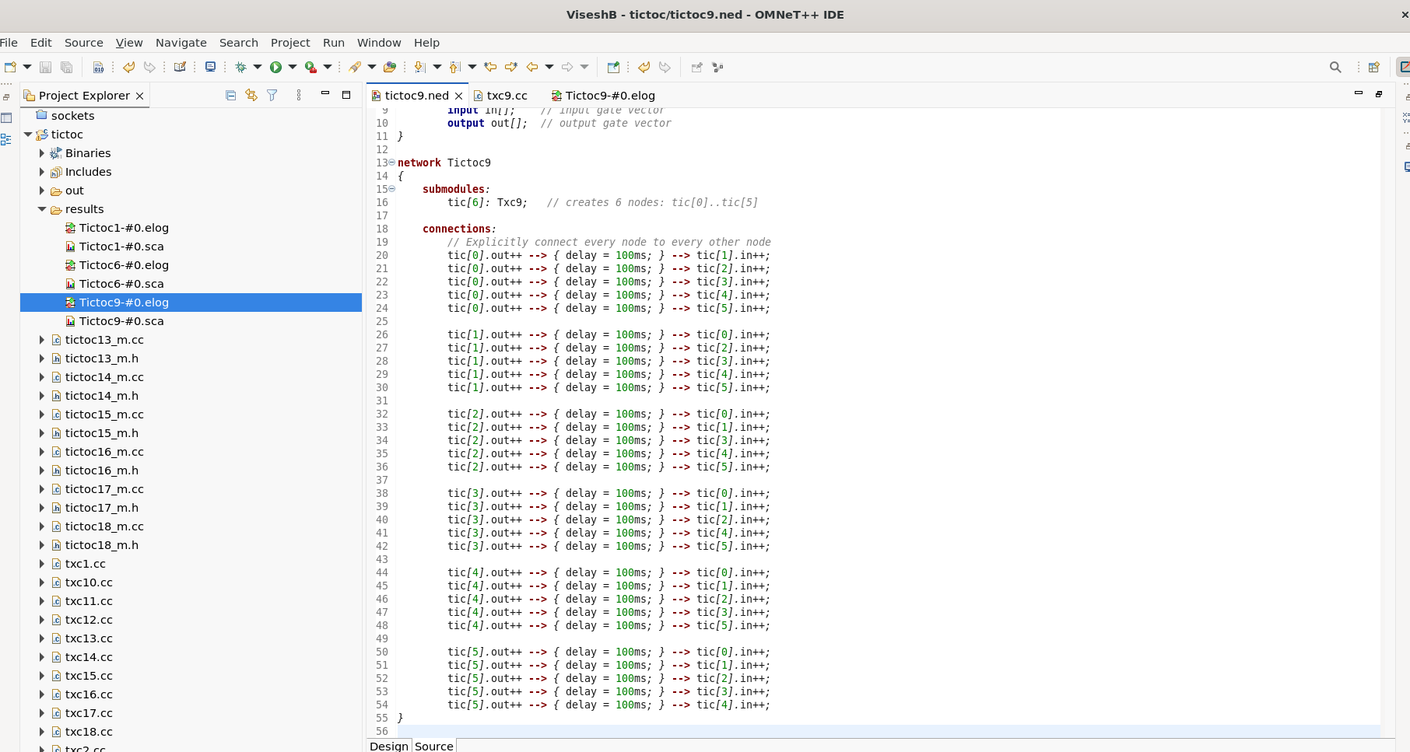
After that we run the omnetpp.ini file and we choose tictoc9

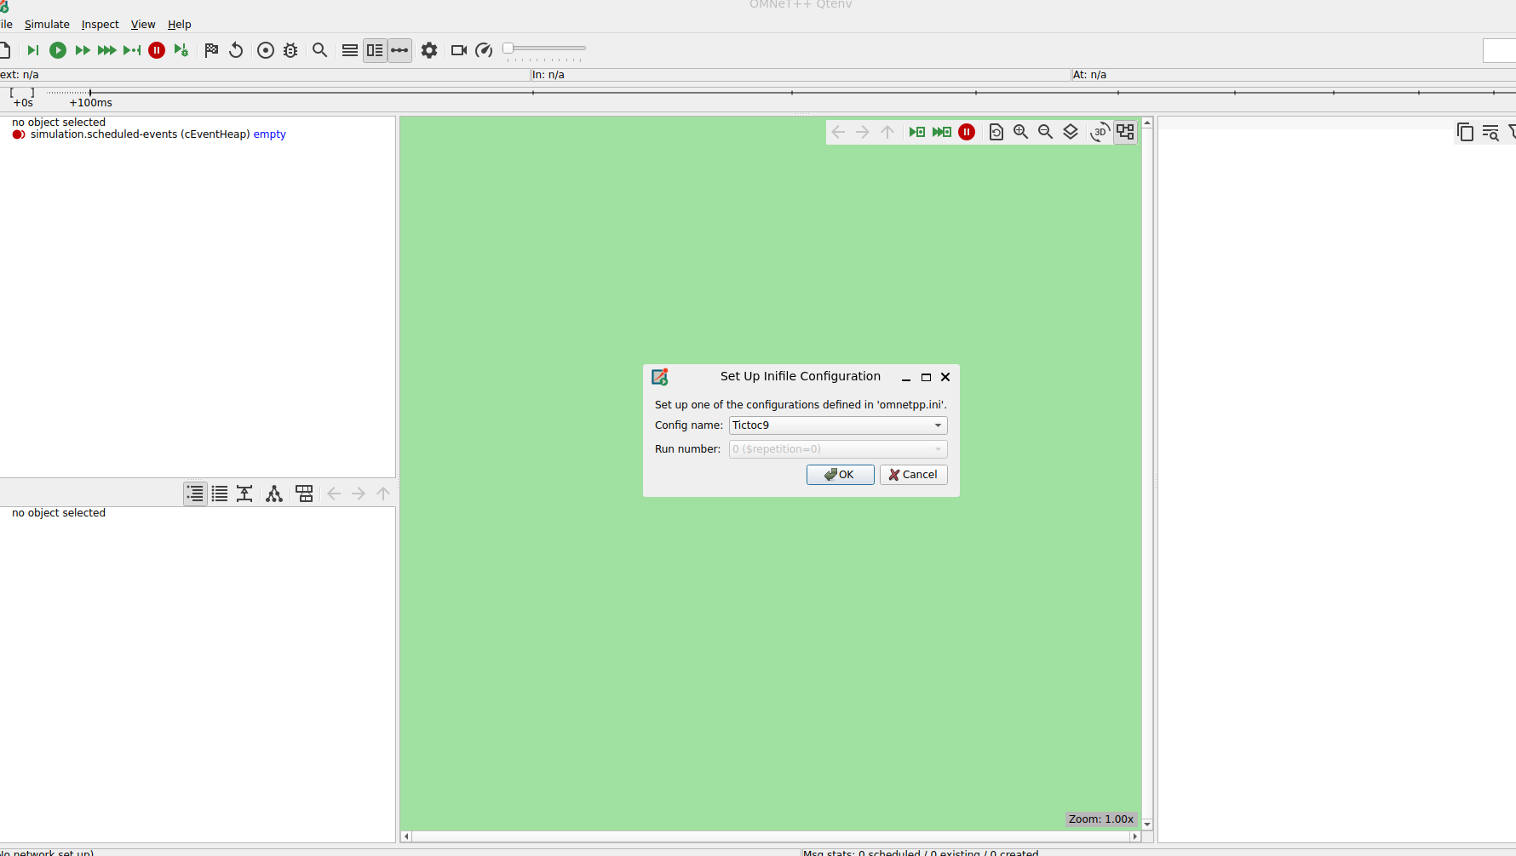

Below is the screenshot of the gui window of tictoc9 with 6 nodes
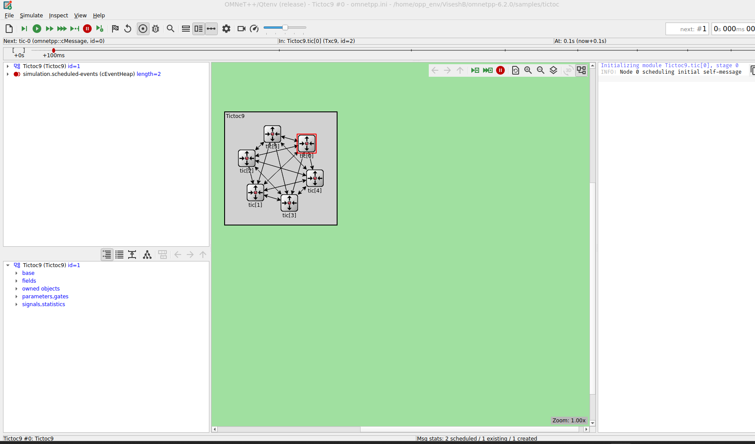

After running it for 2s as per the code ( given in the manual), we can see the simulation below.

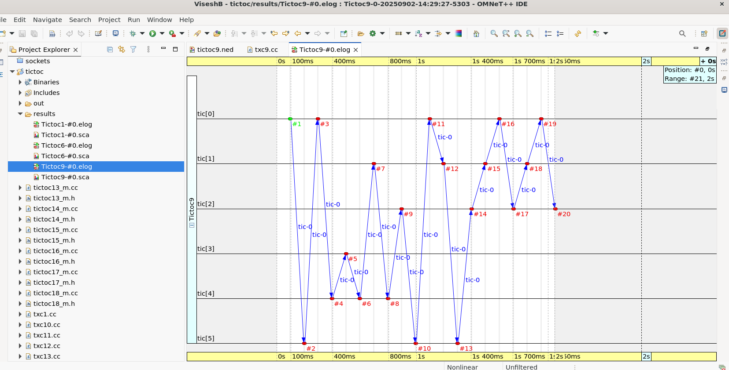
Fifo :
Right click on the Omnetpp.ini, select the event log and the enable the eveny log configuration.
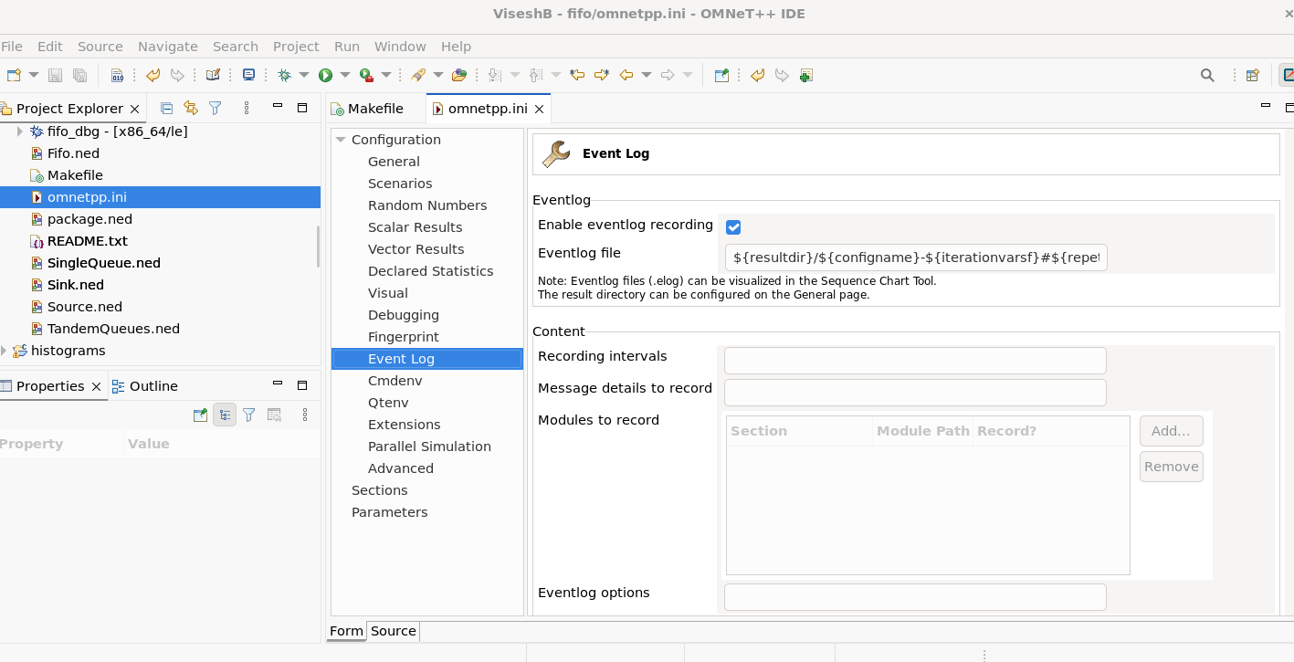
To start the simulation, select the configuration Fifo1 – low job arrival rate from the setup window and click OK

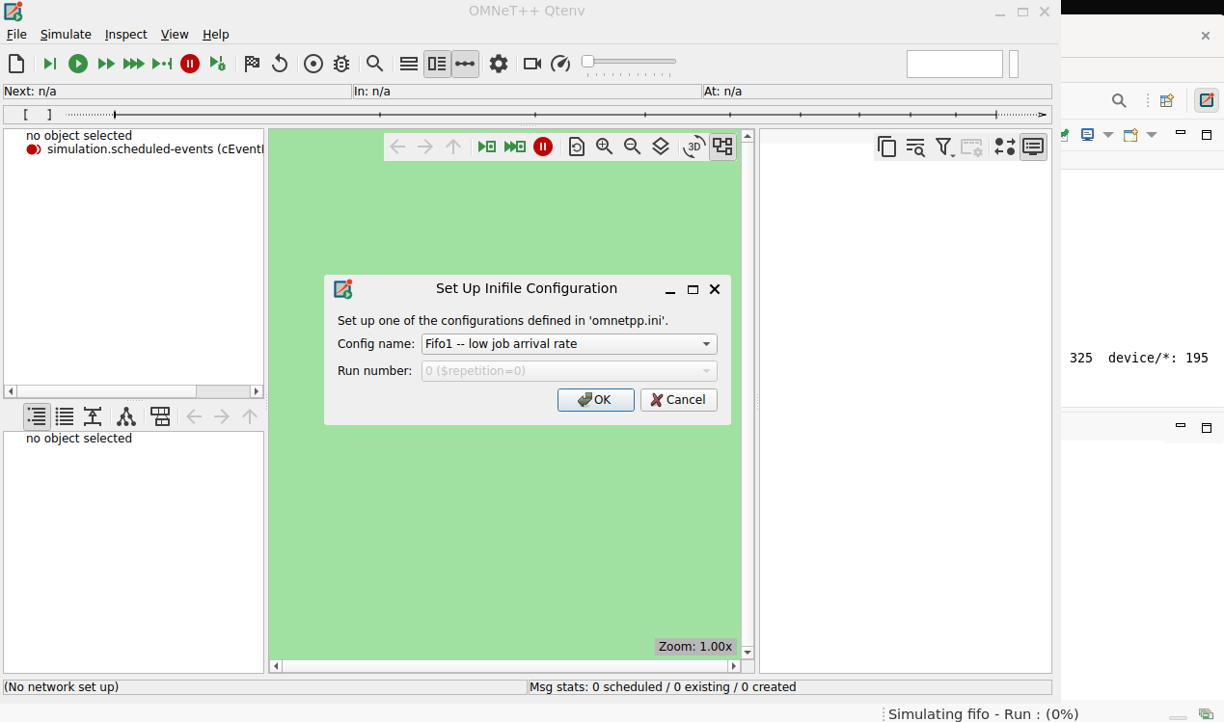
The image below shows the FIFO simulation process with three modules Source, FIFO and Sink.
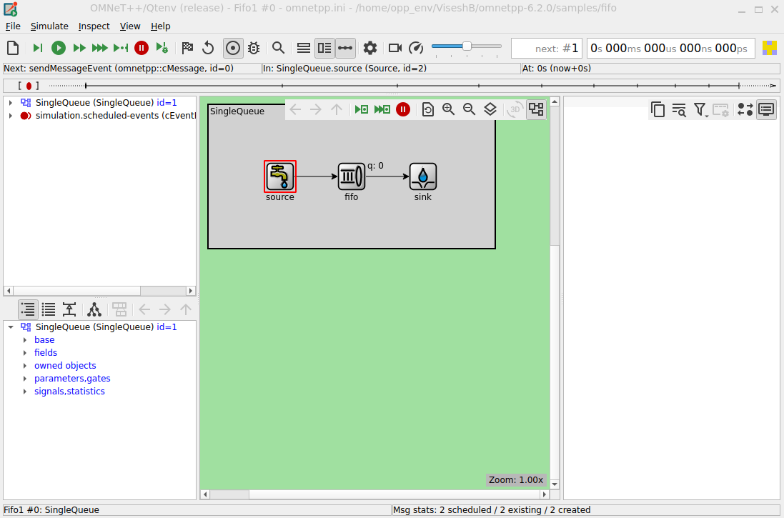

The below image shows the simulator running after sometime we will exit from it.
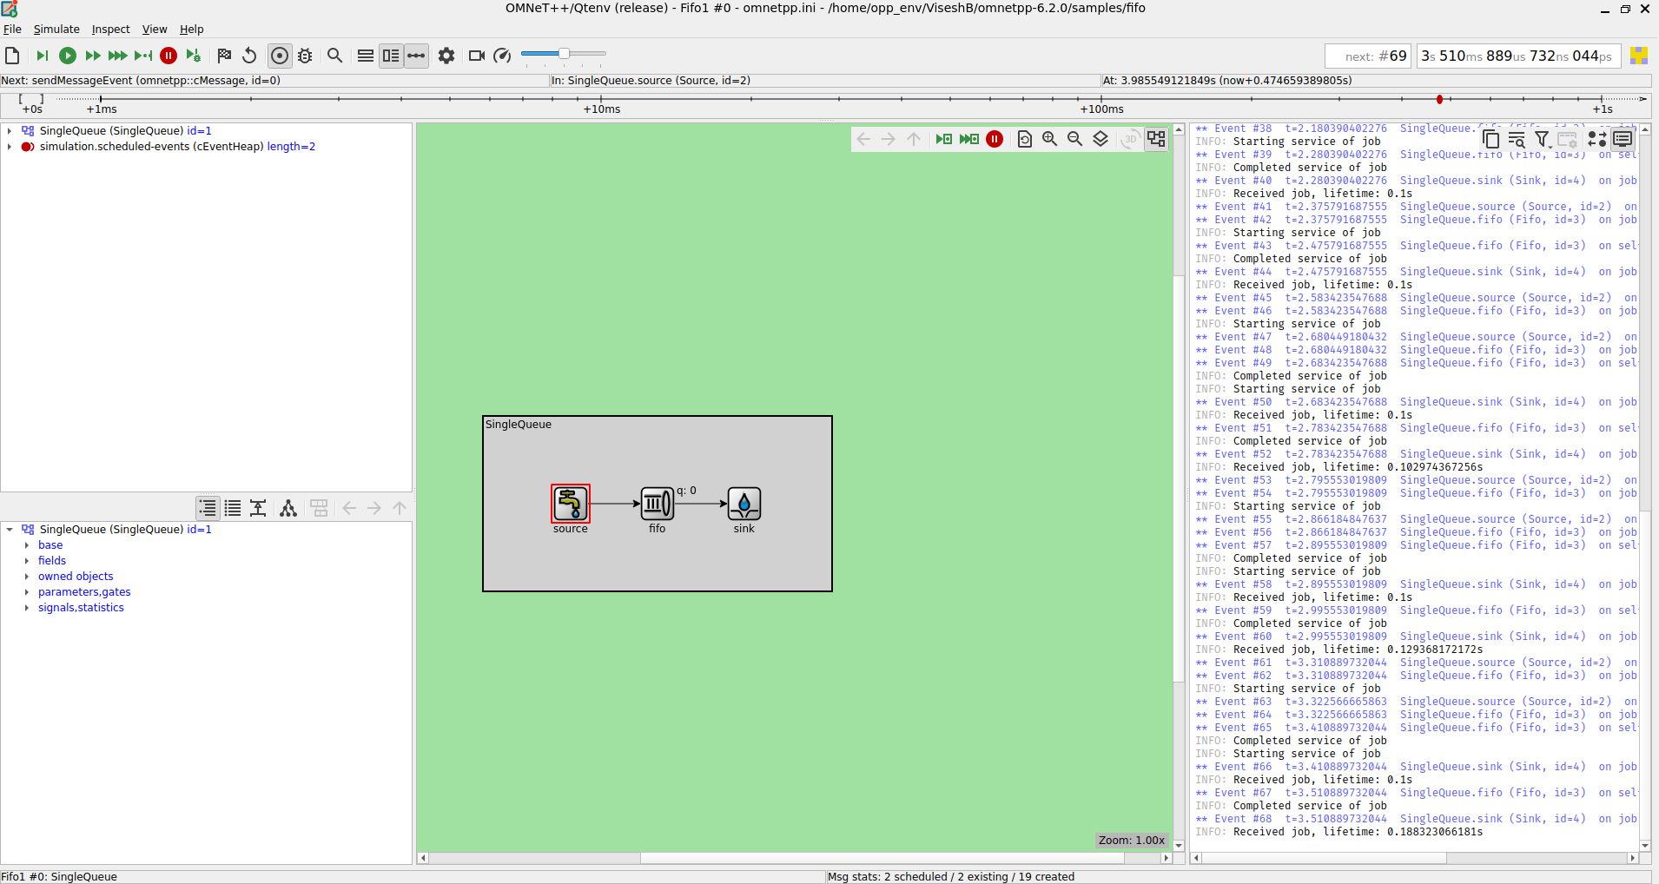

The image below is of event log which shows the flow of messages from Source to sink and then FIFO
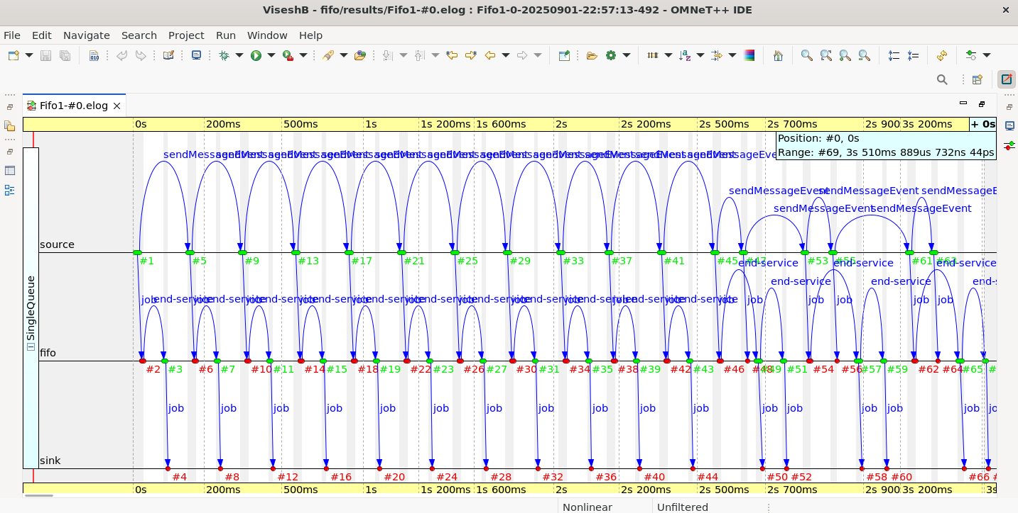
Right click on the event log ,Select Show/hide and then enable the show message reuses
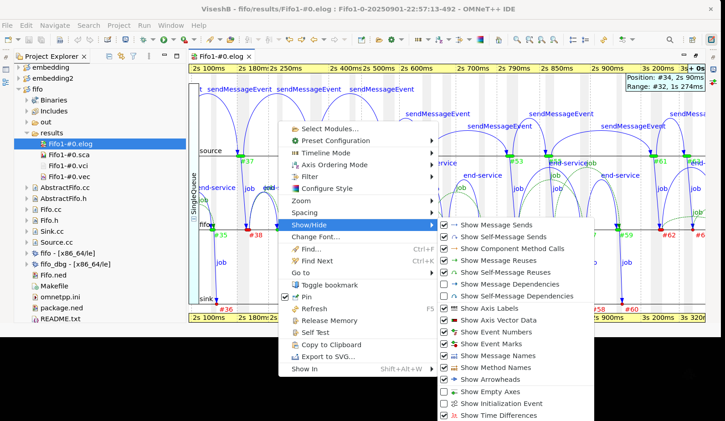

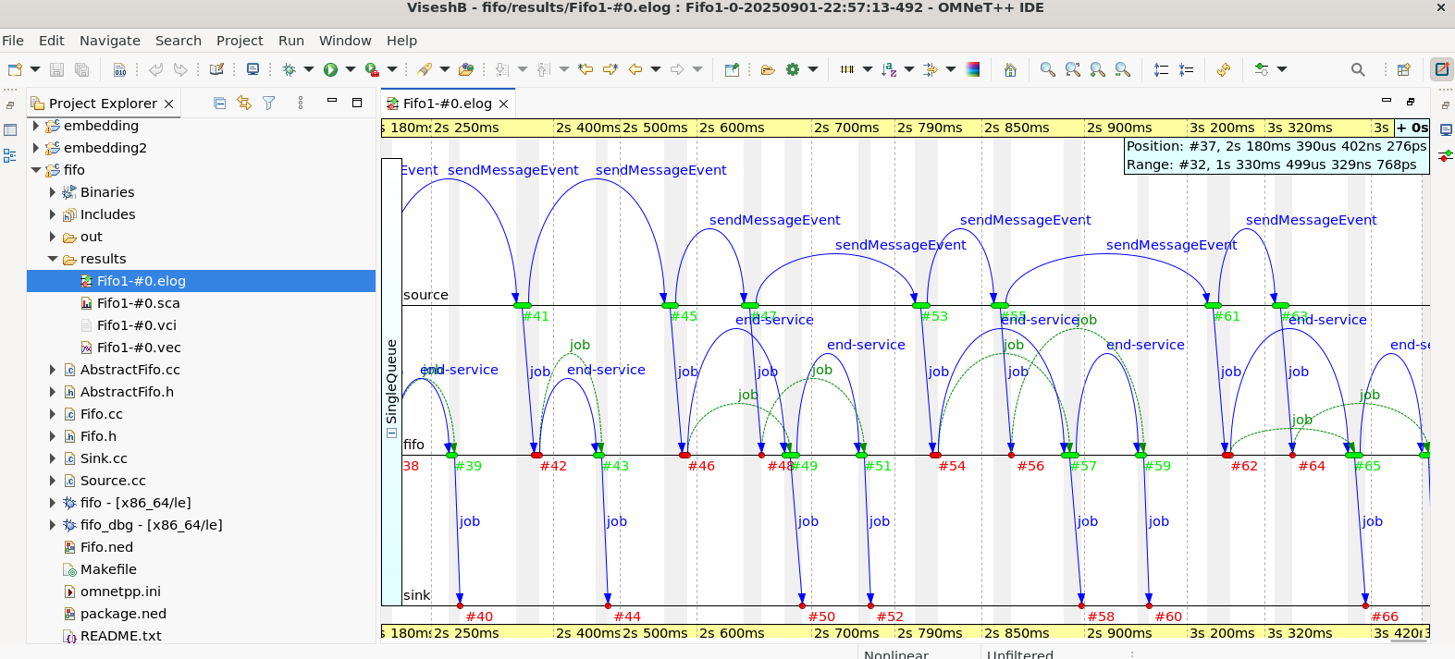
Here we apply a filter for event log by choosing by NED type under the Module filter and selecting both the Sink and Source.
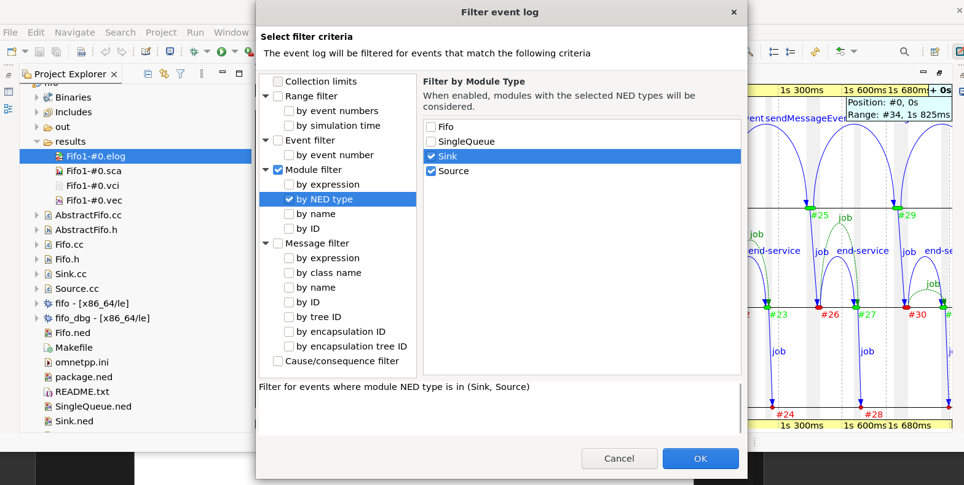

The image below shows the filtered event log where the message are generated at source and then processed at the sink
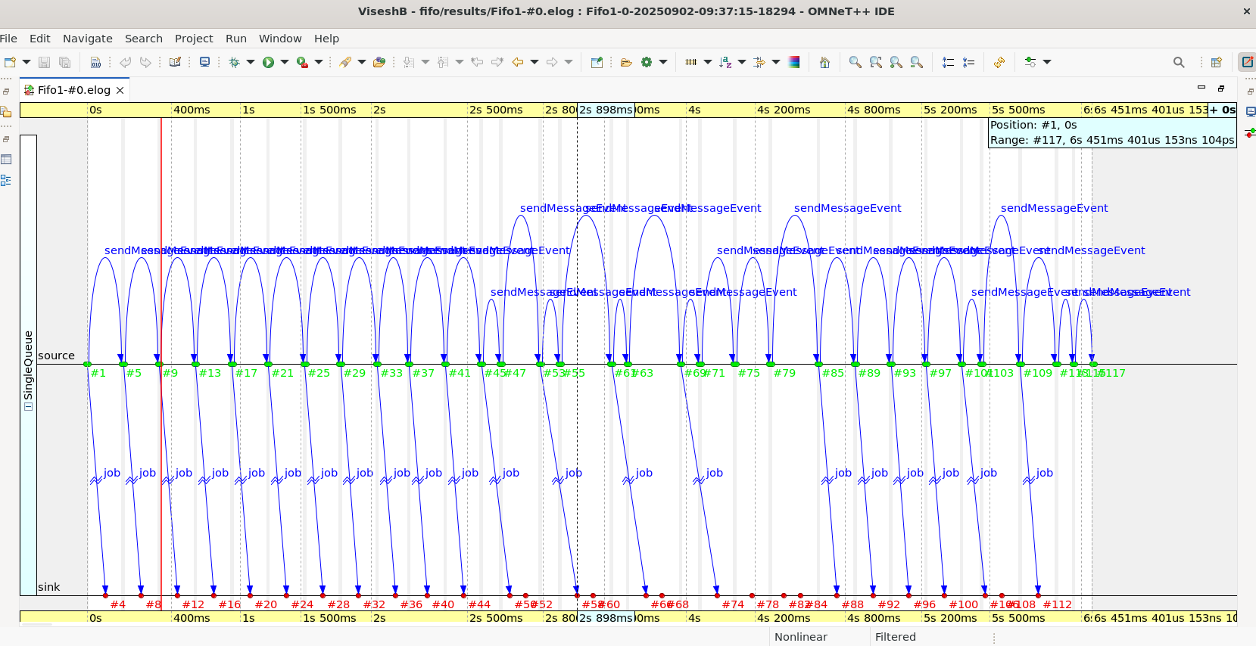

Routing:
Right click on the Omnetpp.ini, select the event log and the enable the event log recording.

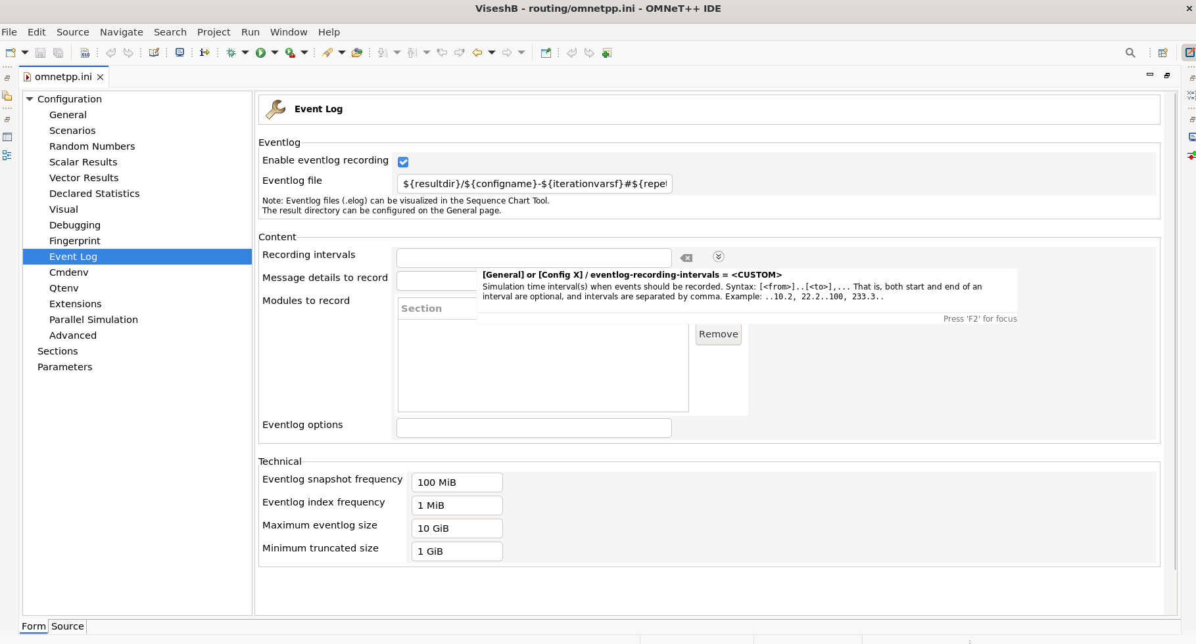

To run the routing simulation,Select the Net10 from the Set Up Inifile Configuration
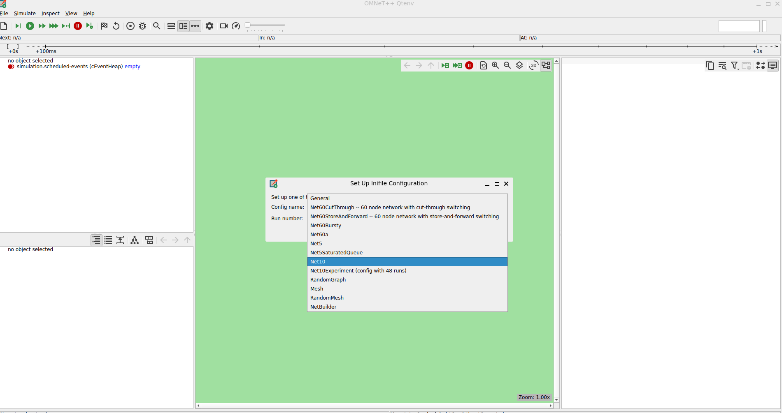

The image below shows the Net 10 simulation with10-node network.

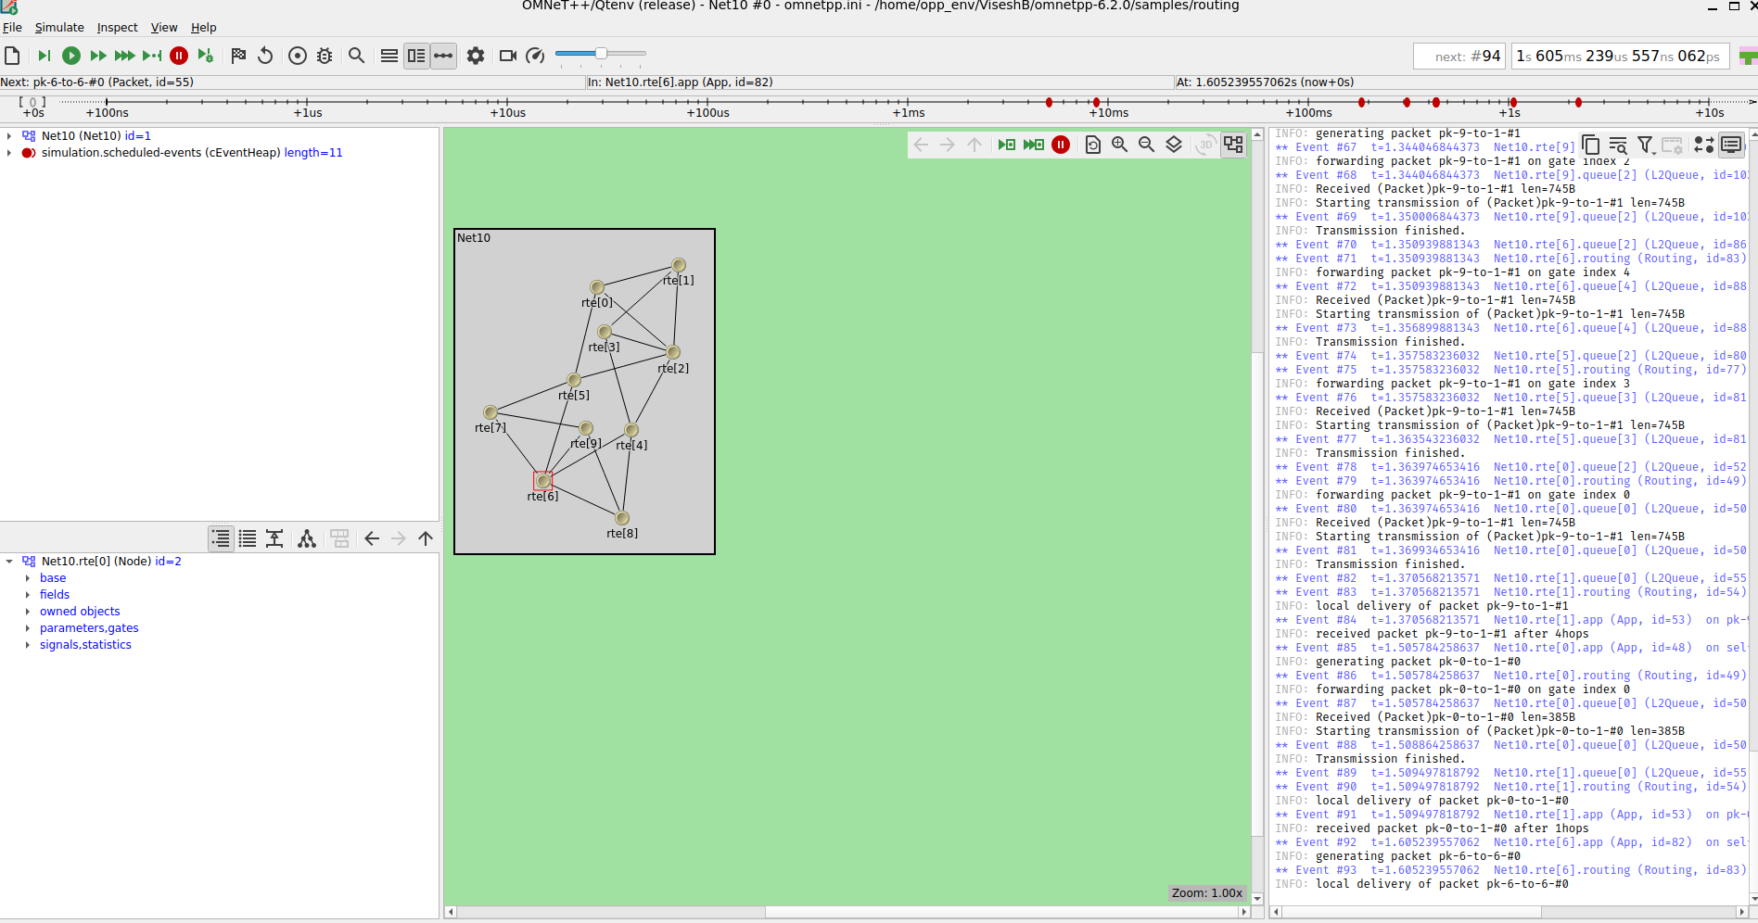
After running the simulation for some time then we exit and look for the logs in the results folder. And we can hover on the graph and we can see the stats

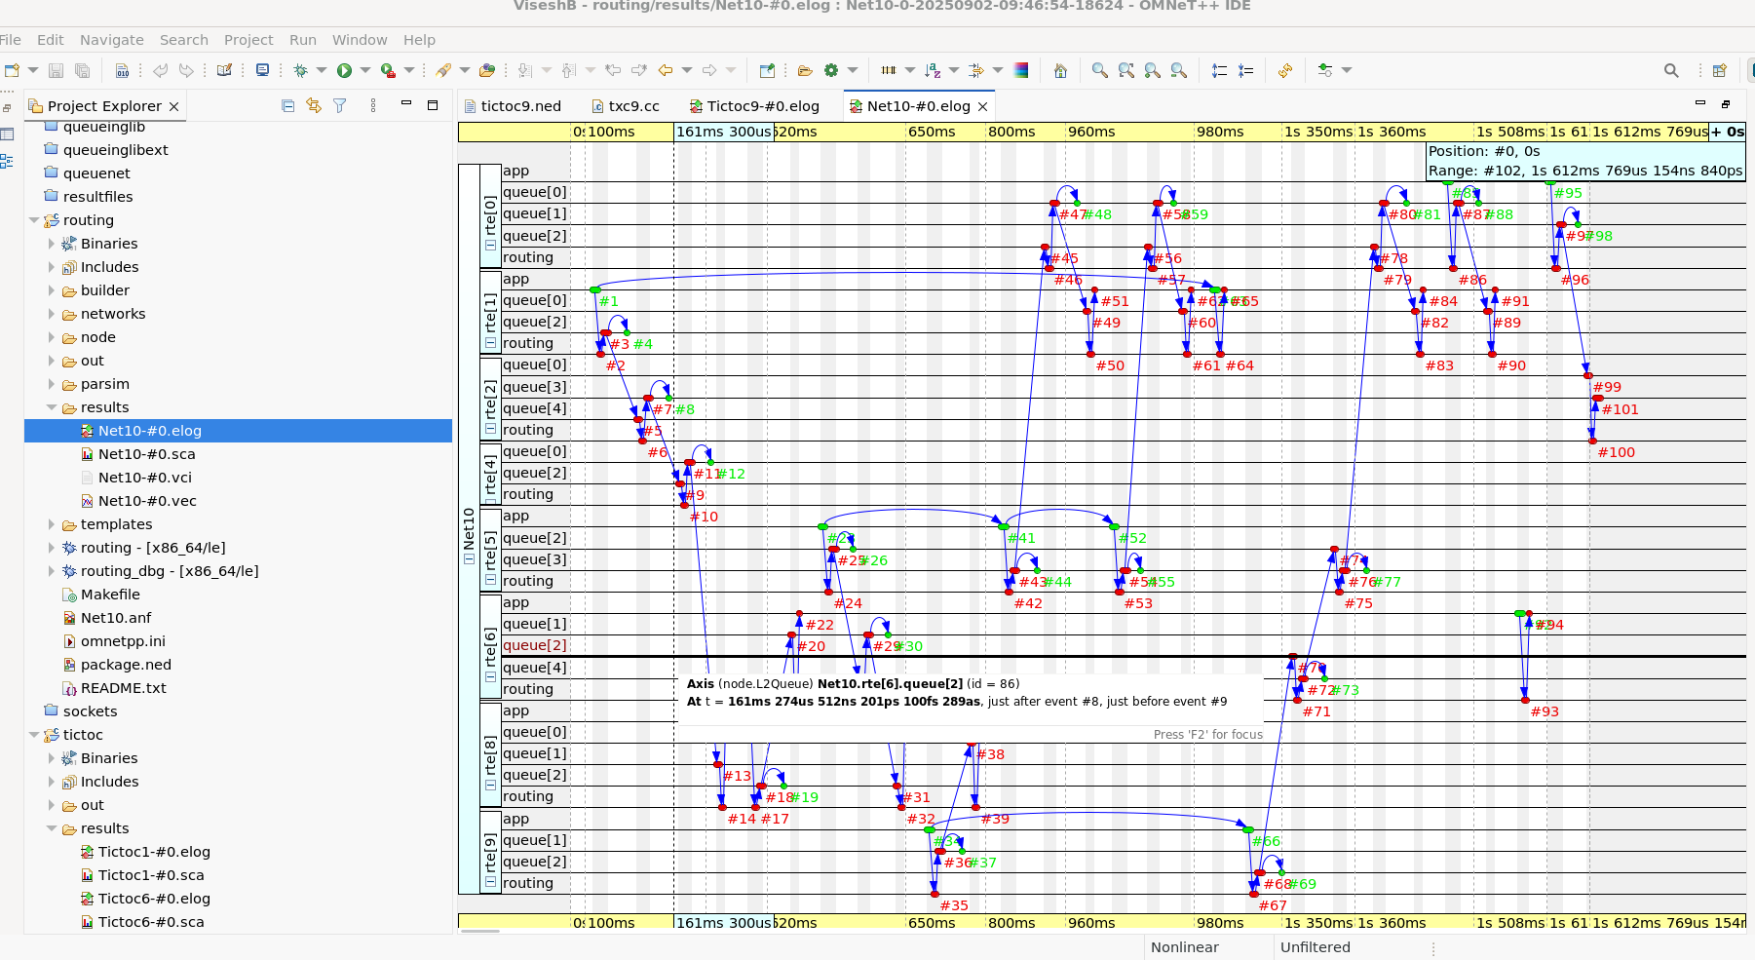

“According to the manual, the next step is to use the filter options. In the Event Log filter section, select Module Filter, then choose By NED type, and finally select node.Node.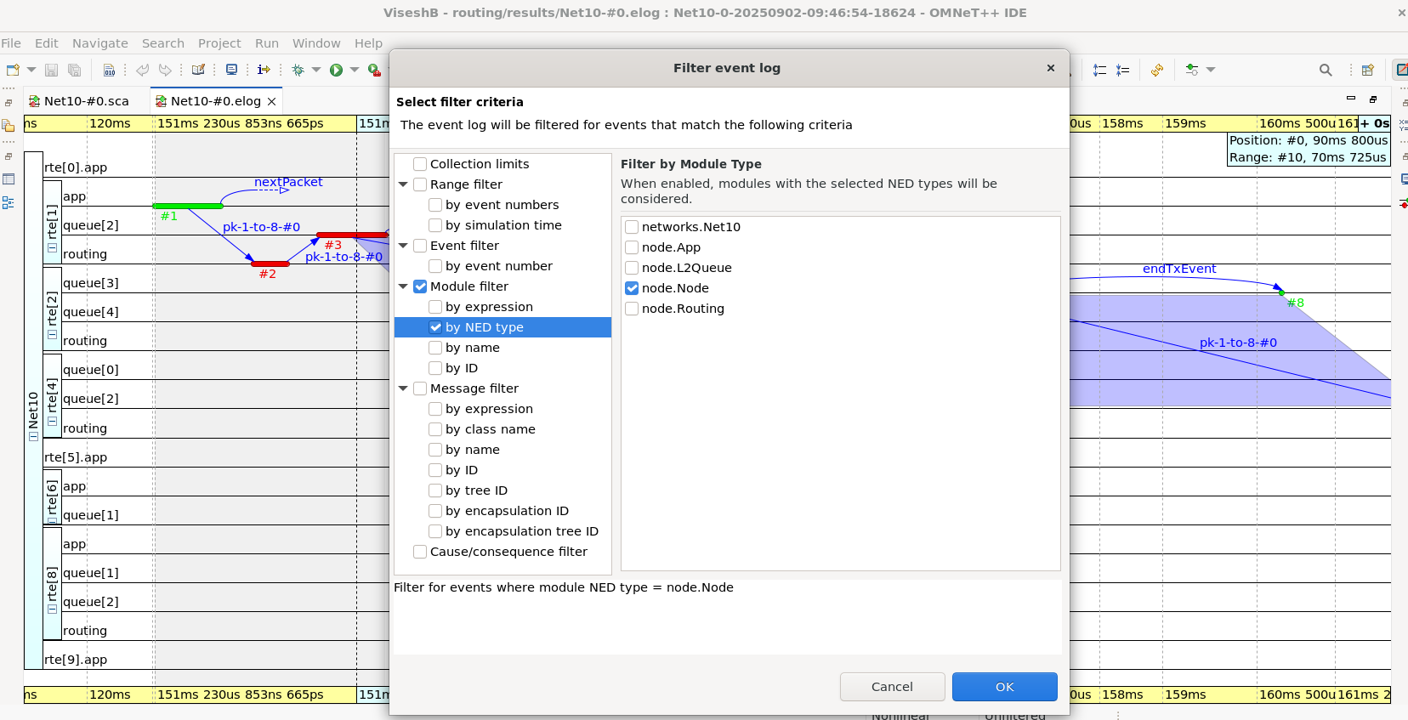
After that we click ok and we can see the graph same as mentioned in the manual
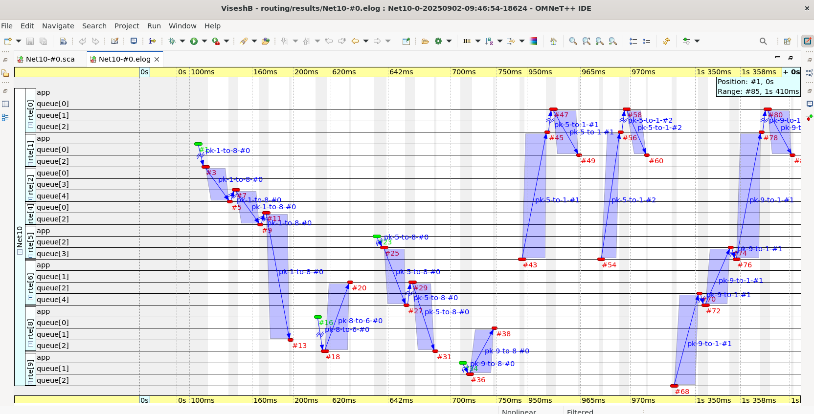

Now, we have to comment out few lines in omnetpp.ini file as shown below
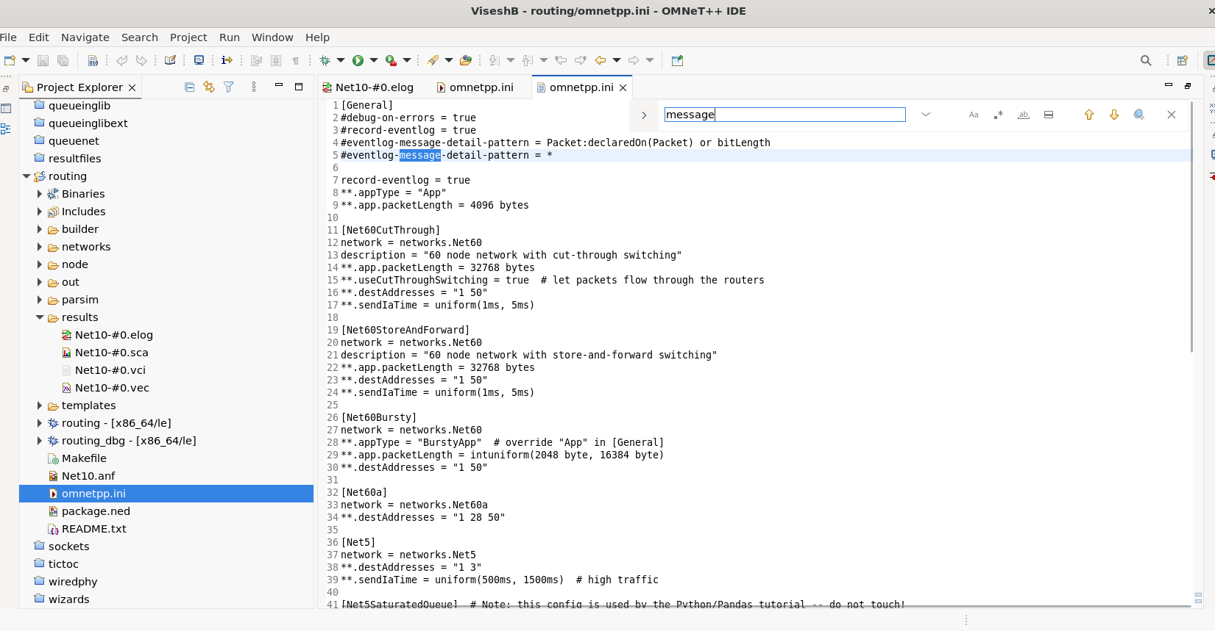

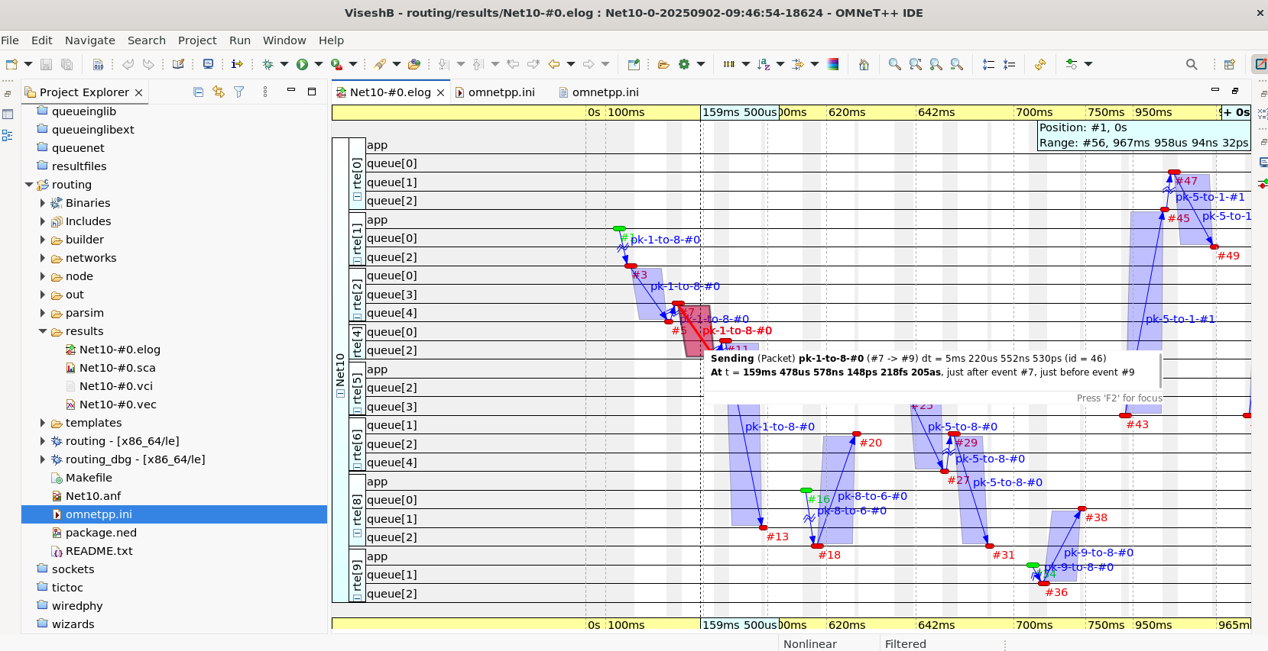

Wireless:
Then to the final example Wireless, which we follow similar steps like before used in examples. We start with omnet.ini and comment out lines and enable event logs
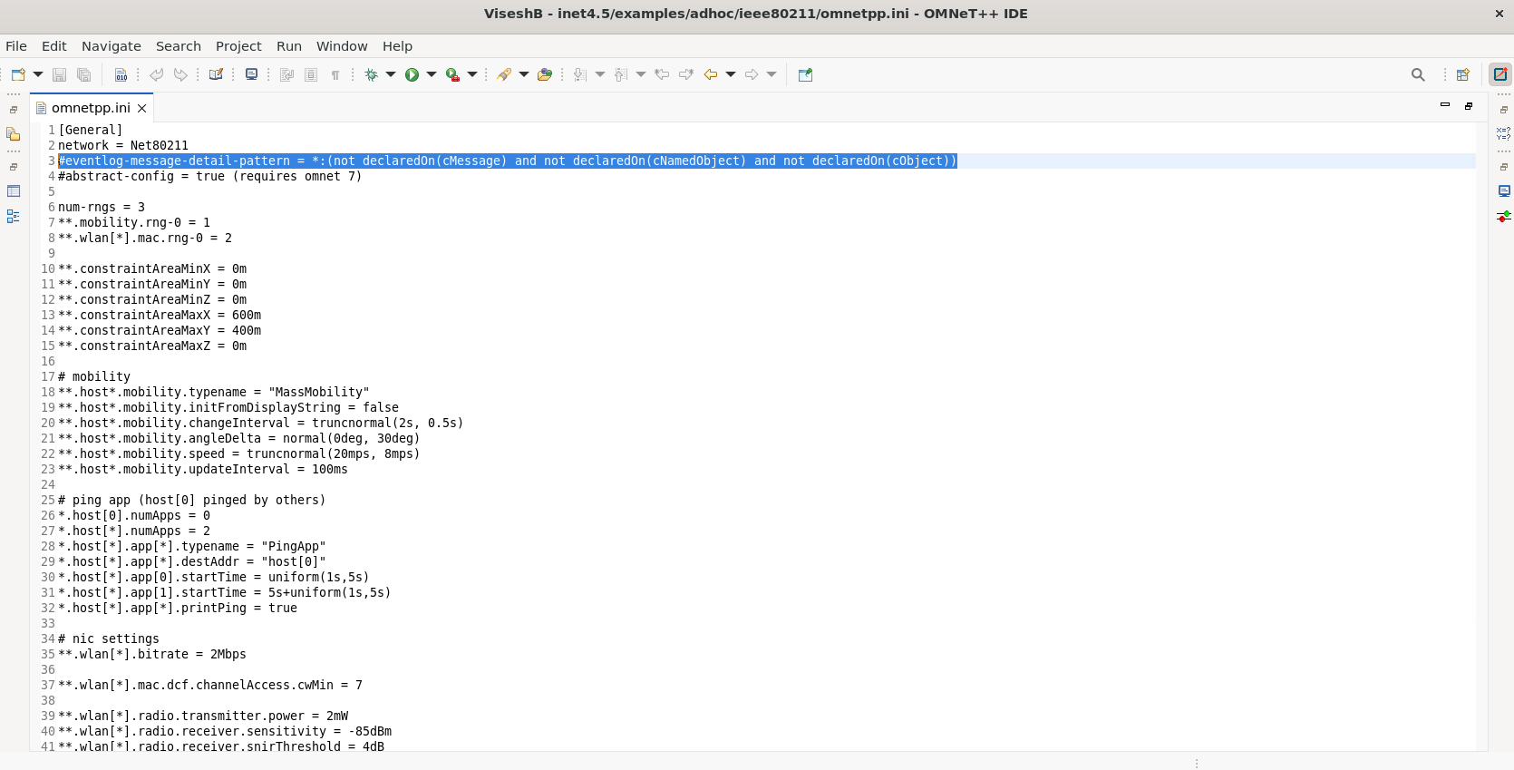
After that when we run the omnetpp.ini file we can see the infile configuration window and in that we have to choose Ping1 – host1 pinging host0

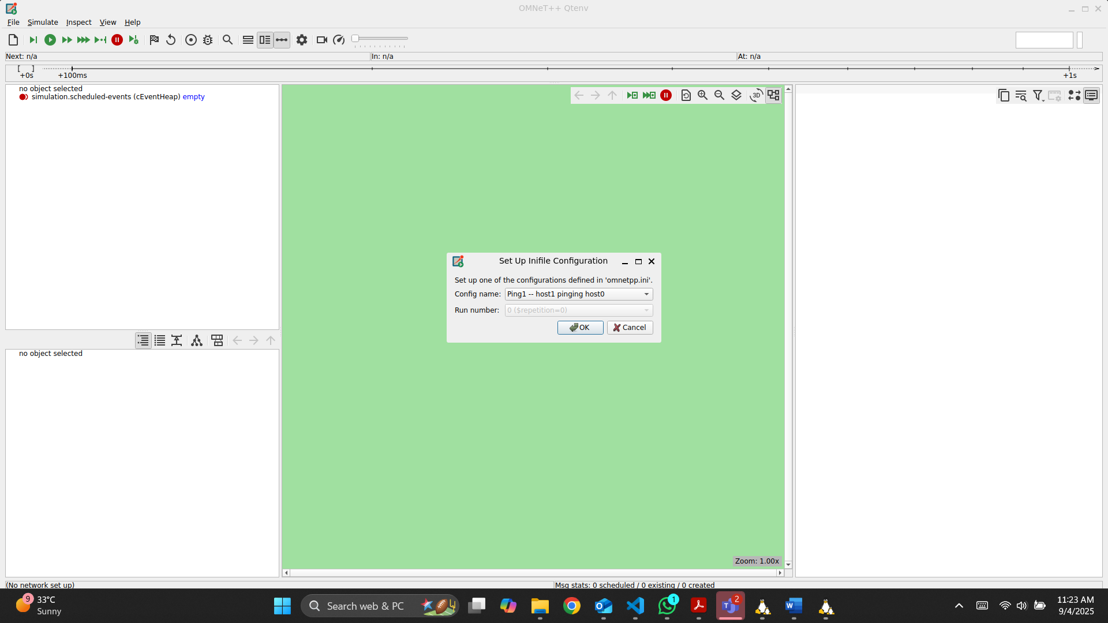
After clicking ok we can the gui windows and then we run it until we reach #5000
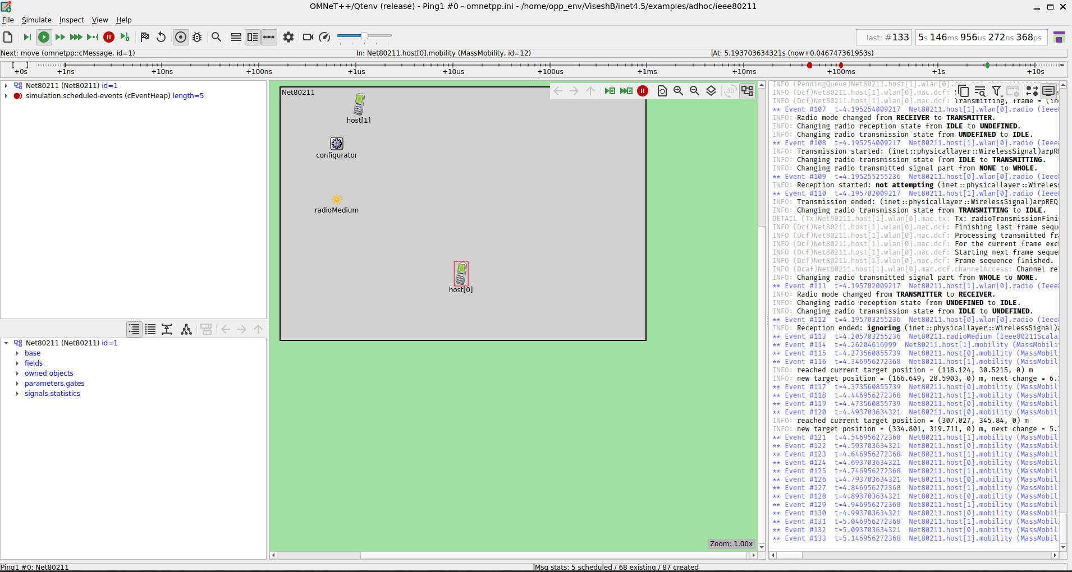

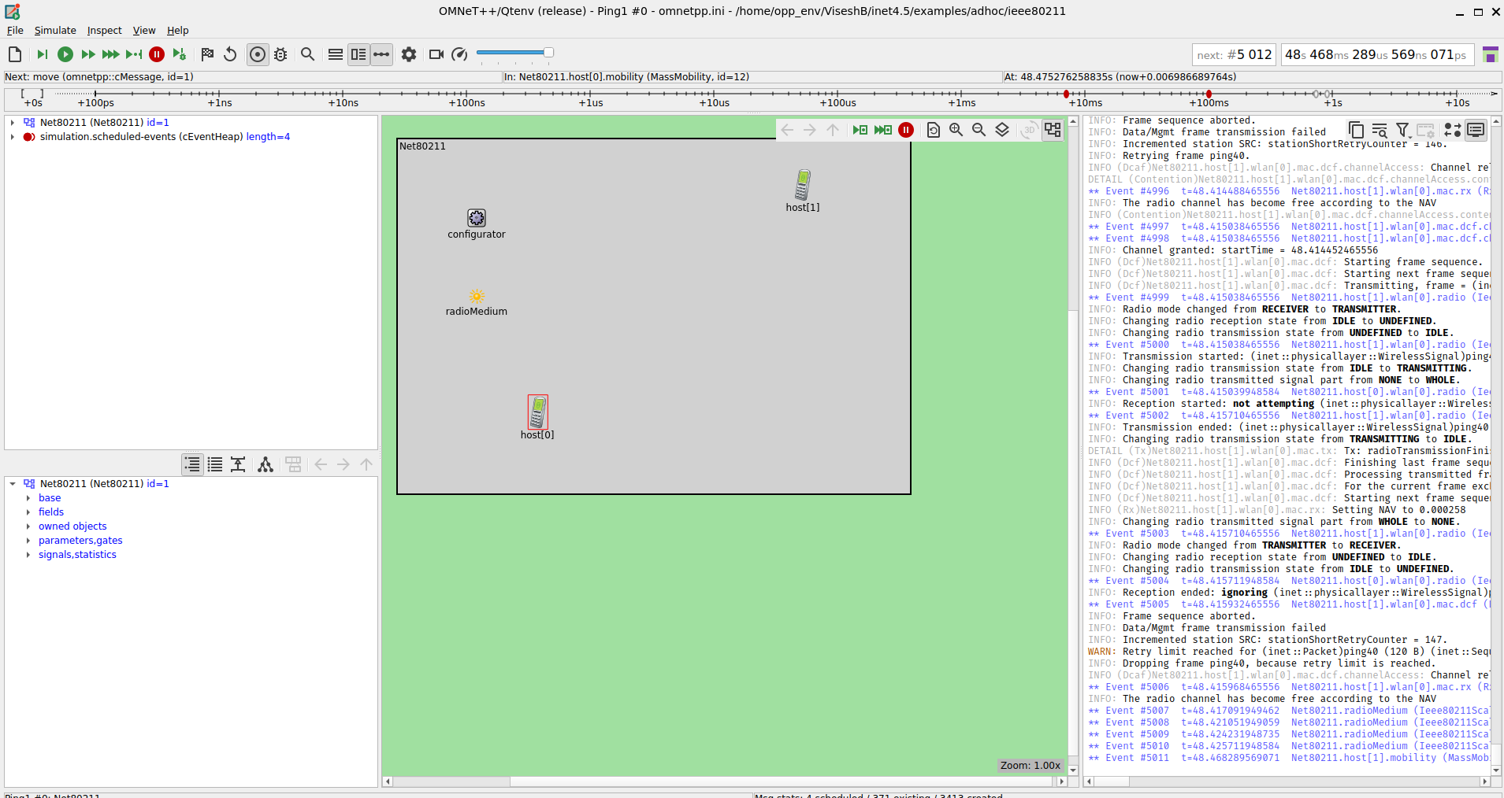
After running for 5000 events now it’s time to close the window and go to event logs and then we can the logs as show in the screenshot below
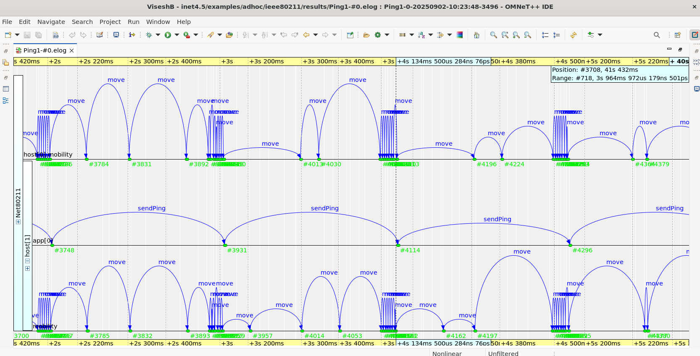
As said in the manual we choose 3 modules. 2 from host1.wlan0 and 1 from host0.wlan0.
and the click apply and we can se the below graph

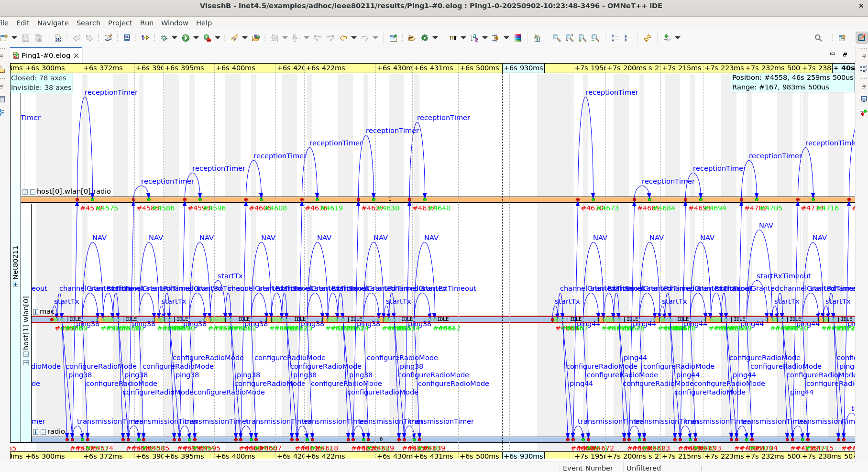
After that we add mac from host0.wlan0 just like from the manual
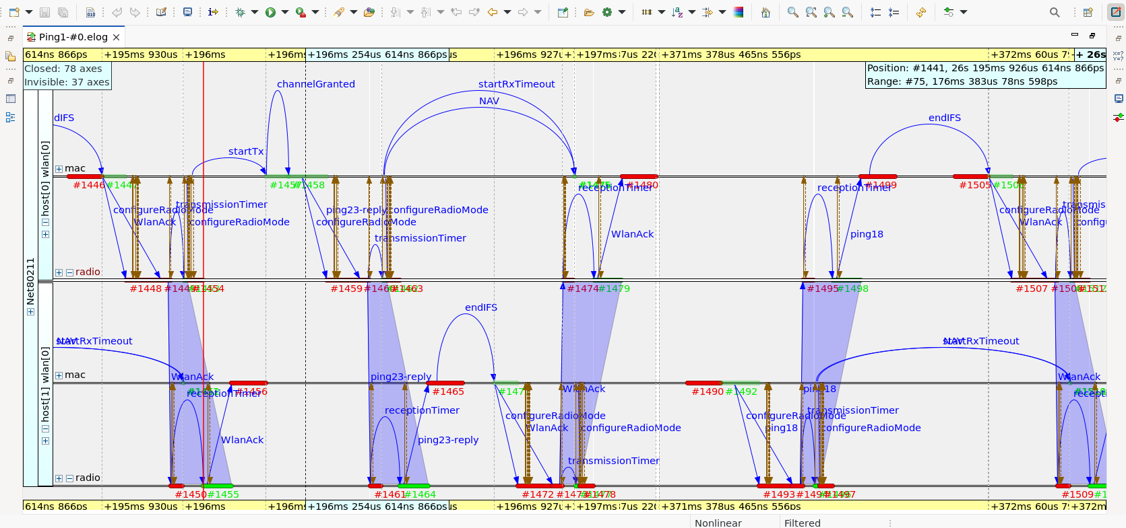
Now, we have to bring the radio’s together by manual axis ordering and we can change them by using the top or up or down options as we can see it below in the screenshot

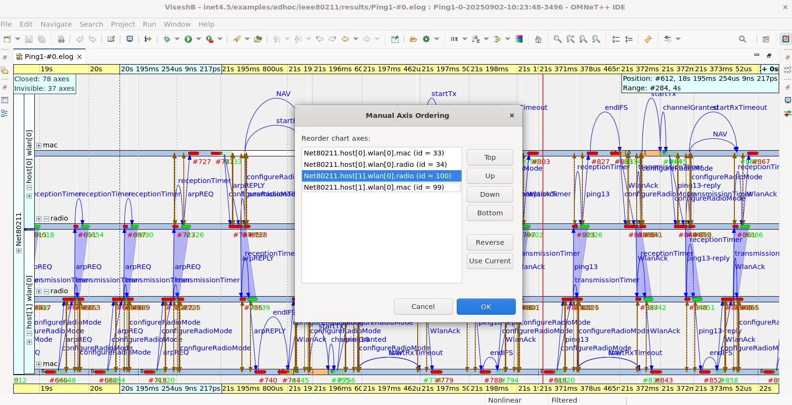

The Ping1 simulation shows wireless communication between two nodes using IEEE 802.11. Messages such as arpREQ, transmissionTimer, and receptionTimer are exchanged, demonstrating successful transmission and reception over the radio channel.
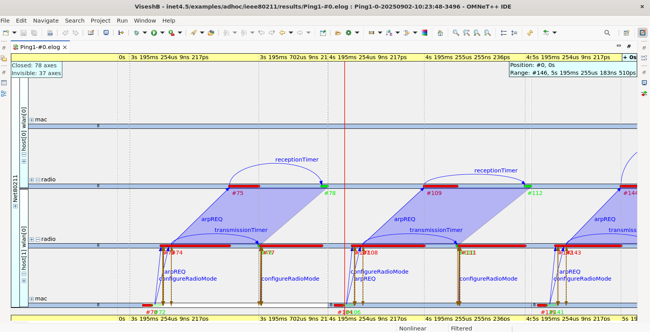
The Ping1 simulation log shows detailed IEEE 802.11 communication with events like arpREQ, arpREPLY, WlanAck, and transmissionTimer. It demonstrates message exchanges, acknowledgments, and proper radio configuration between nodes.
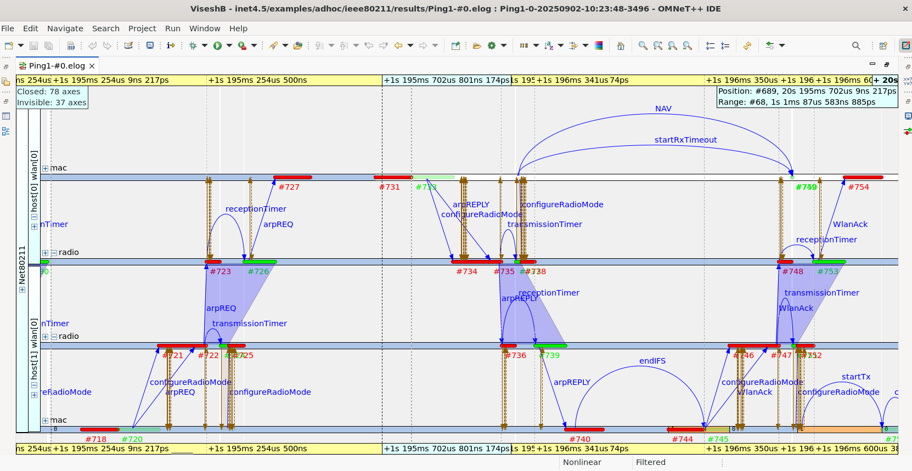
The graph shows a successful ping exchange between two nodes. The process begins with the ARP request, followed by the ARP reply, allowing the nodes to discover each other’s MAC addresses. Once the ARP stage is complete, the ping request is sent from the source node and successfully received at the destination. The destination then replies with a ping response, and acknowledgments (WlanAck) confirm the delivery. This sequence demonstrates a proper and complete ping communication cycle between the two nodes.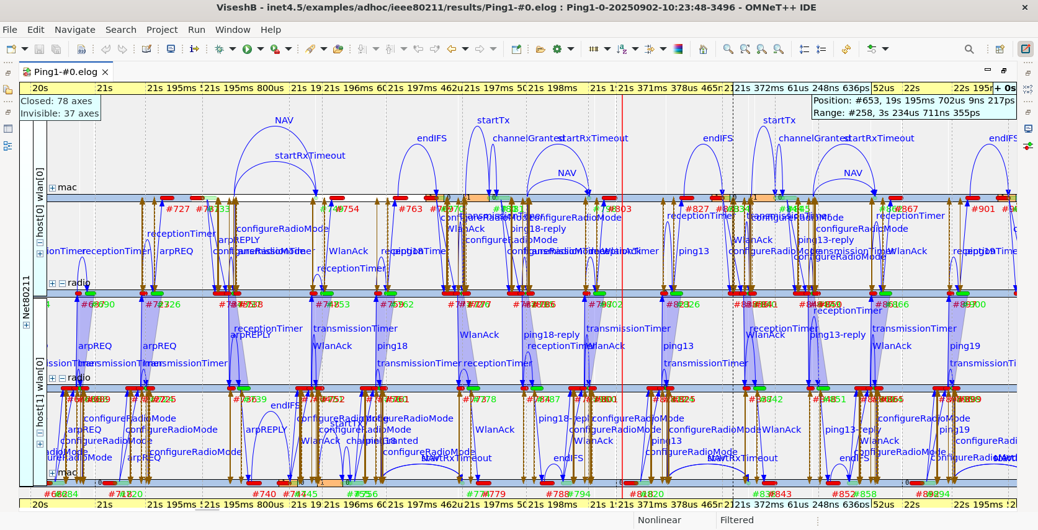
The graph shows an unsuccessful ping transmission. The source node sends the ping30 message, but due to issues such as weak signal or interference, the packet fails to reach the destination. Although events like transmissionTimer and receptionTimer are triggered, the retries eventually end without success, and the message is dropped. This shows the case where the ping does not complete successfully.
